TASK1: Simple Signal Handler:

Write a C++ program that handles the SIGINT signal (Ctrl+C) gracefully by printing a custom message before exiting.

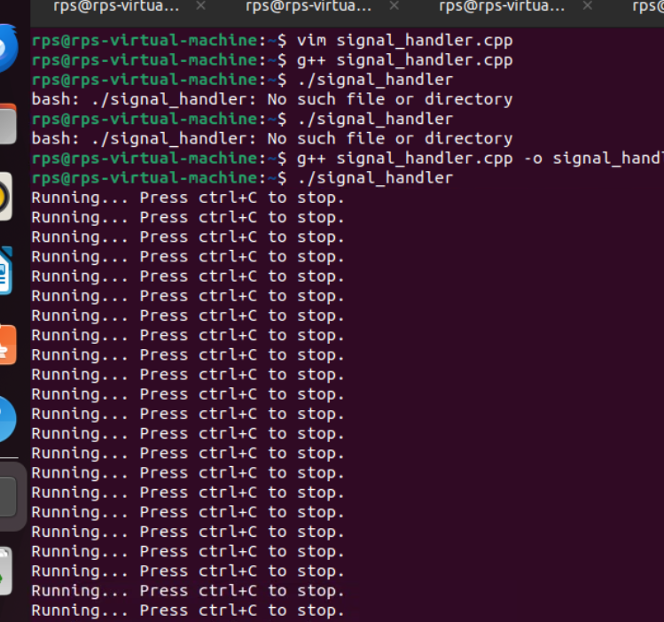

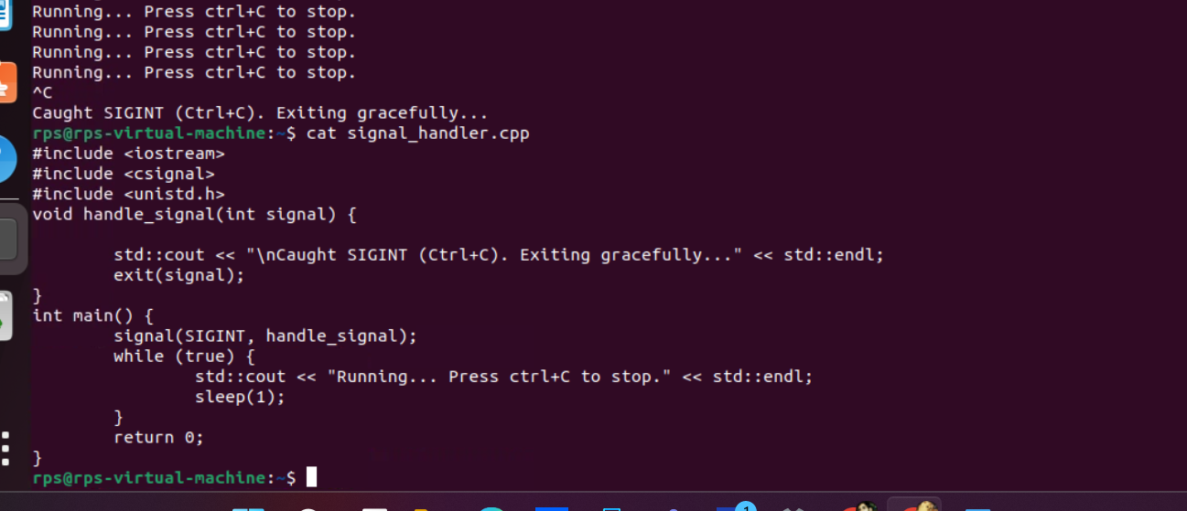

TASK2: Multiple Signal Handling:

Create a program that handles both SIGINT and SIGTERM signals, printing a different message for each.

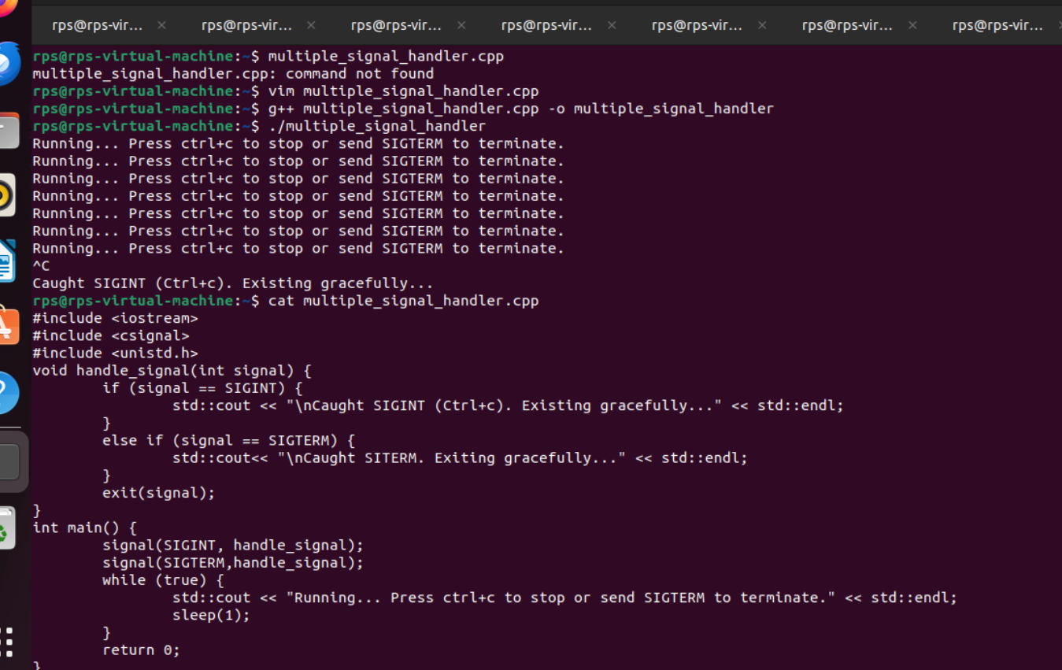

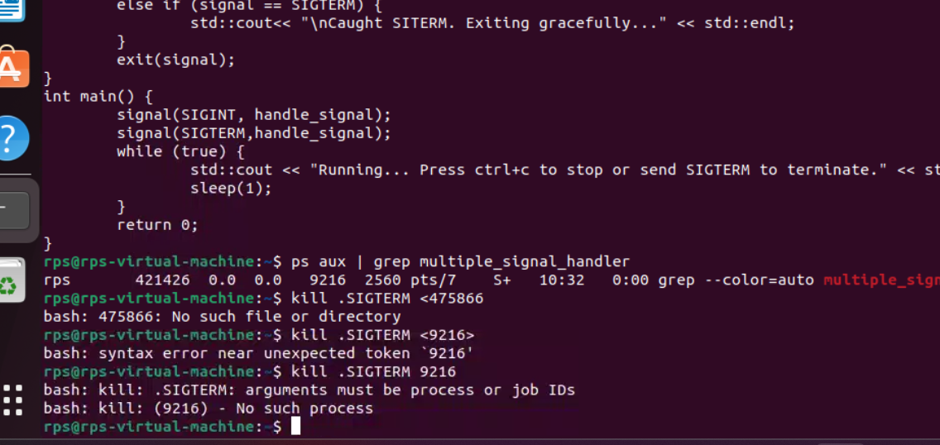

TASK3: Ignoring Signals:

Develop a program that ignores the SIGTERM signal and continues execution even after it's sent.

